LOGO COMPETITION SHEET

Dear PROJECT TEAM MEMBERS,

This sheet has been prepared in order to choose the logo of our partnership project. The logos are made by the students in each partner country. This partnership, as known, consists of 7 partner schools but we have 16 logos. Nobody knows which logo belongs to whom except for their own logo. Therefore; each partner has 14 points ranging from 1 to 14 for the logos. Give point 16 to the logo you like most and 1 to the one you like least. The logo which gets most of the points will be chosen.
Complete the ASSESSMENT SHEET. First in Chart 1 you have to vote for the PROJECT LOGO. Before voting think about that this logo will be used in all project documents. The project title and the programme should be clear and visible. Then in Chart 2 you have to vote which one of the logos from the exhibition reflects the most the project idea.

LOGO 1

LOGO 2

LOGO 3
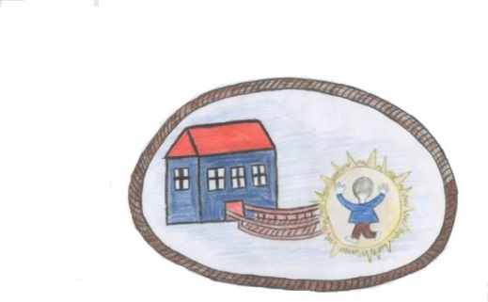

LOGO 4

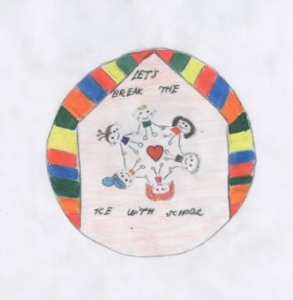

LOGO 5

LOGO 6

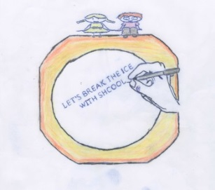
LOGO 7

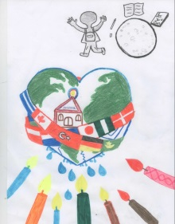
LOGO 8

LOGO 9

LOGO 10

LOGO 11

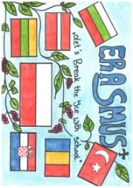
LOGO 12

LOGO 13

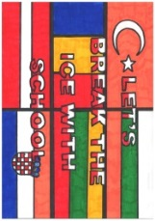

LOGO 14

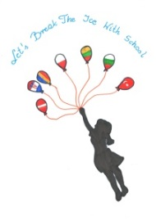

LOGO 15

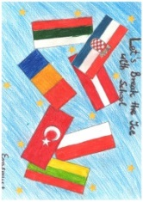

LOGO 16

